1. In the original code, there was only line 71 in the image without judgment about ‘m_traj_T’. From the diagnostic information we can infer that the value of the variable ‘m_traj_T’  is zero, which will make the index exceed the range. So I add an ‘if’ to deal with this special situation. However, I’m not clear yet what values should be assigned to jerk_cmd(1:6) (here I simply choose all zeros, which may be inappropriate)

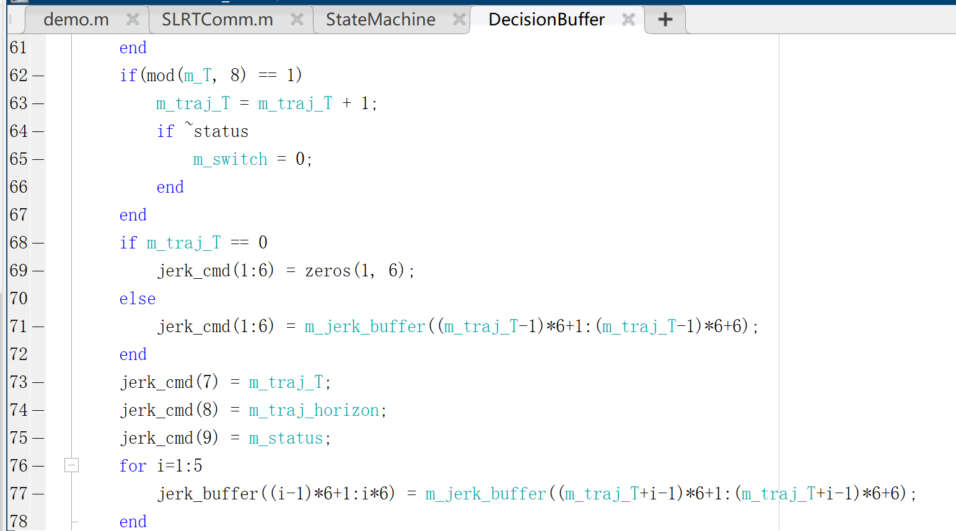

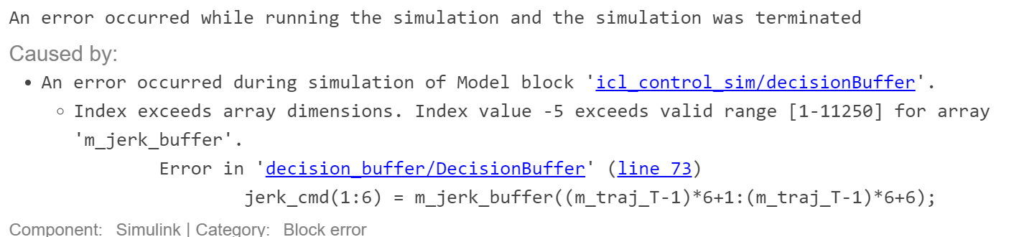

1. The problem is shown in the following image. The error is not in assignment but in getting the cross-product.

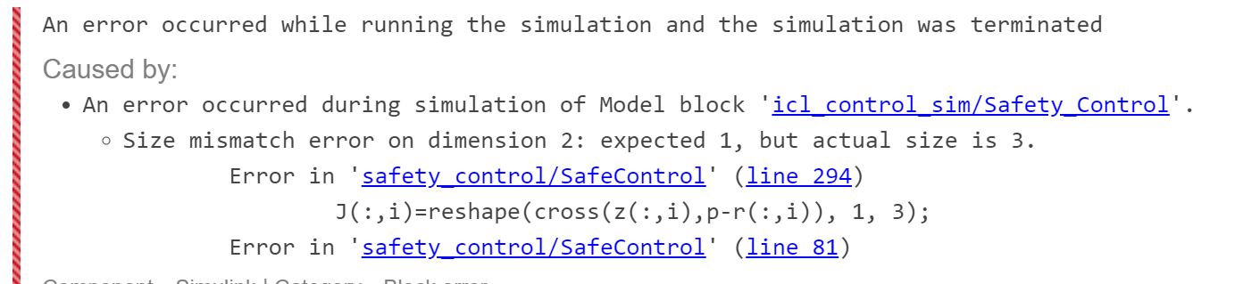

Solution:



1. line 46 is from the original code. There is a size mismatch on both sides of the equal sign. Elements on the left side are less than that on the right side.

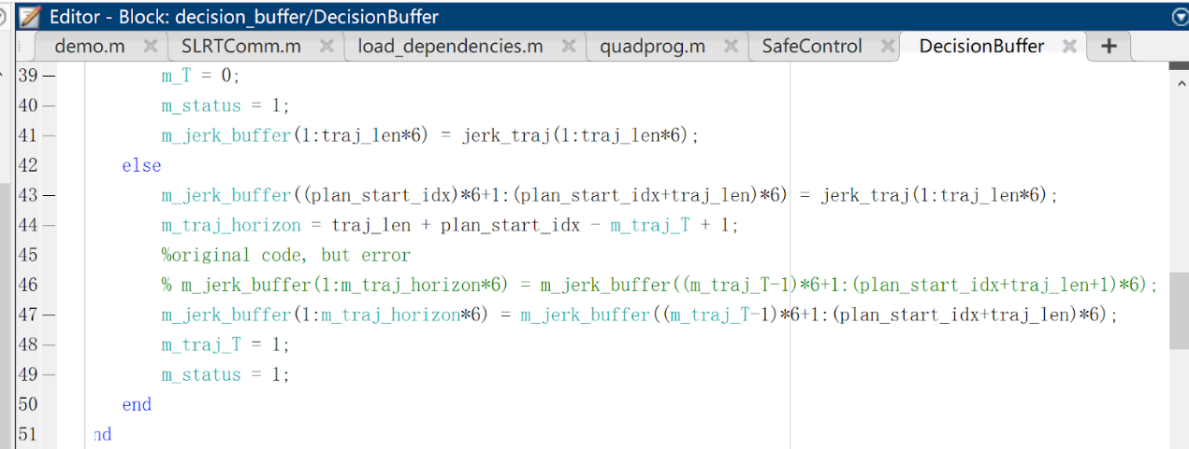

1. As the comment shows, the variable link1 and link2 are originally initialized to be 0. But 0 is an illegal value for array index, once link1&2 are not assigned new appropriate value, it will cause error later.

